Todo for Andy
Listed in preferable order of priority.
- Rig character
- Basic sword model
- Basic shield model
- Basic sand groundtexture
- Basic pillar model
- Attack animation
- Walk animation
- Basic Javelin model
- Advanced sword model
- Advanced shield model
- Advanced Helmet model
- Figure out the game’s colour scheme.
- Sword, Shield, Javelin and helmet texture
- Advanced pillar model
- Pillar texture
More to come I imagine, once the art style, colour palette and setting has been nailed down.

Reference images:

Sword
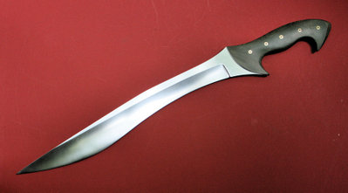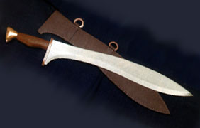

Shield
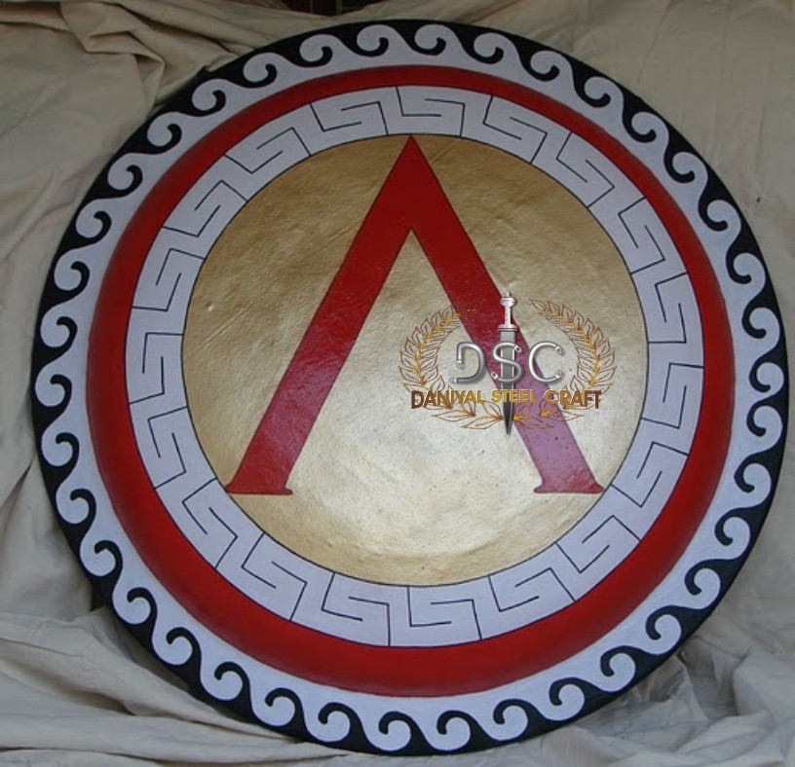
You get the drift right, round, curved on the inside, some kind of straps for your arm etc.
The detail on the front could be done with bump mapping in the future; just keep it smooth for now.

Helmet
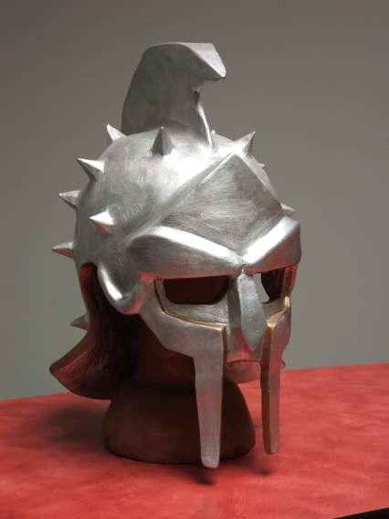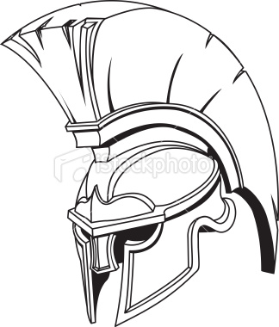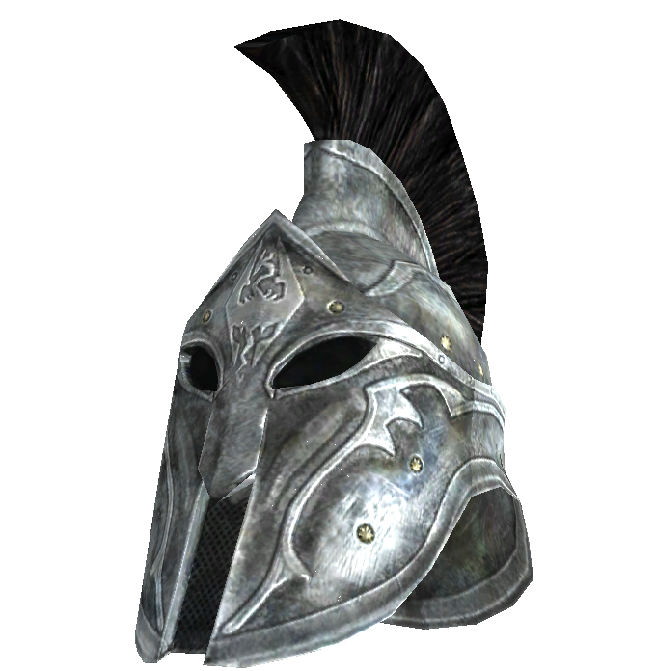
Some kind of mixture between greek and roman. I really like the brushes on the top. Keynote: Try to hide as much of the face as possible to allow us to have bad faces.

Javelin
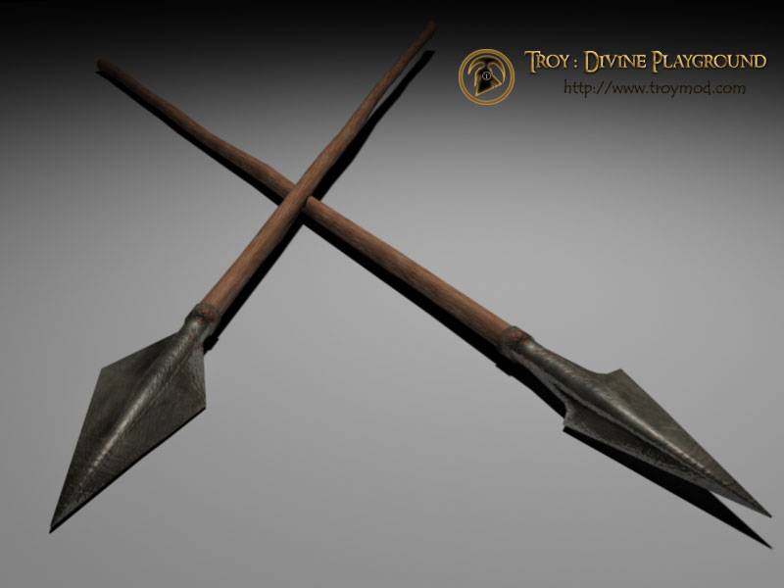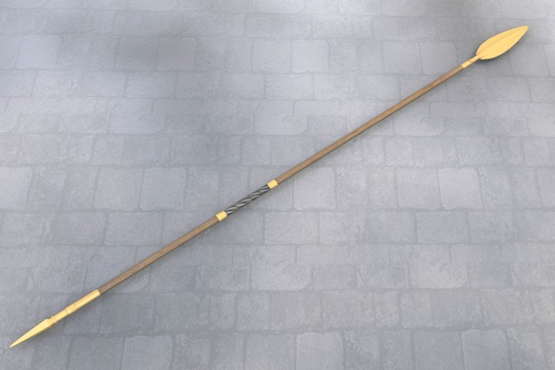

Pillar
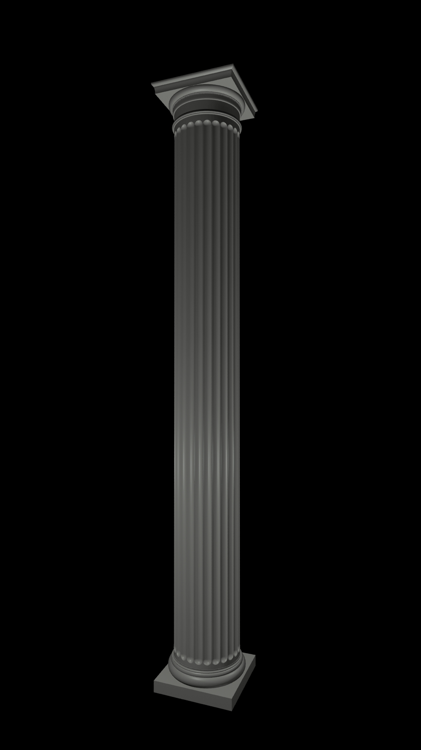
Note: Greek, not roman. Greek pillars are simpler in their design, worthy of an arena.

Sand texture
You know, just sand. Hard sand which is walkable.
